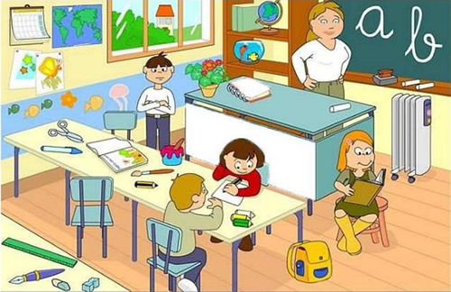

https://www.google.com/search?q=DIBUJOS+DE+ENTORNOS+ESCOLARES&rlz=1C1GGRV_enCO751CO751&source=lnms&tbm=isch&sa=X&ved=0ahUKEwjH4Jmm5vrgAhUrzlkKHZQODQEQ_AUIDigB&biw=1366&bih=576#imgrc=SiOB6JrnWzQLGM:

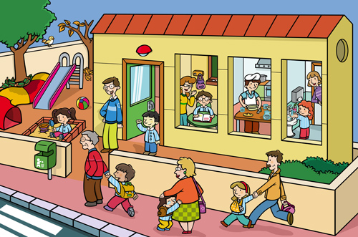

http://edublogmetalunermb.blogspot.com/2013/04/tema-11-como-elaborar-diagnosticos_3448.html

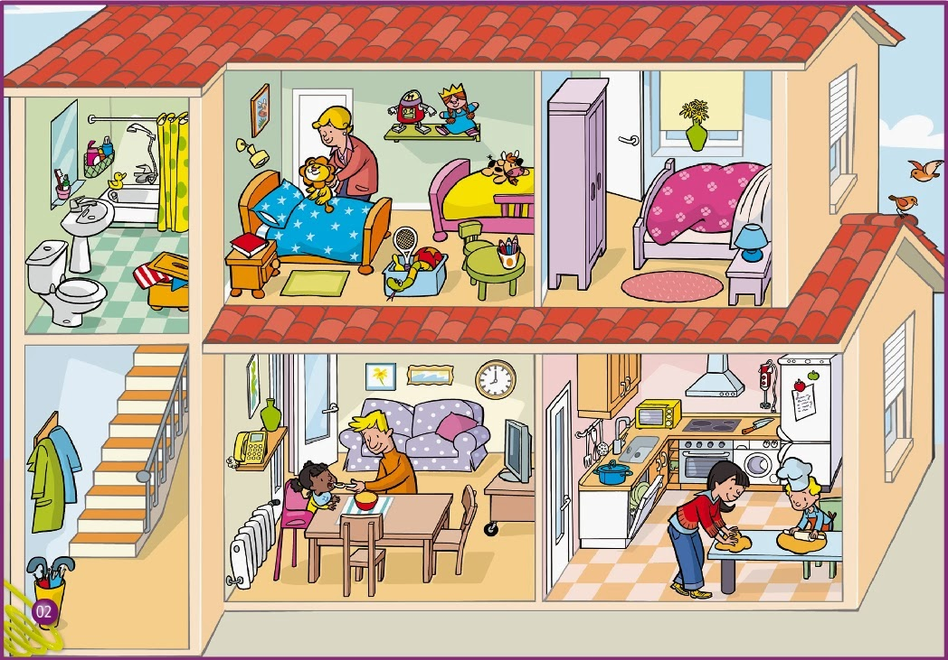

https://www.google.com/search?q=DIBUJOS+DE+ENTORNOS+ESCOLARES&tbm=isch&tbs=rimg:CUojgeia51s0Ijj47cuUw8EYGrvZO80zJXp52sqgyYhPh_1EQ_1coqWk6isyxM1Yd-cT3MAyE30TL3xB9AQ69DASsVHSoSCfjty5TDwRgaEZ9eFdQp1-2HKhIJu9k7zTMlenkRCy5wOTd06GYqEgnayqDJiE-H8RE-lIDlocSFzioSCRD9yipaTqKzEc5VJhw41KoXKhIJLEzVh35xPcwRRjACY1nxcr8qEgkDITfRMvfEHxHMhIrTzhv5PyoSCUBDr0MBKxUdETZV0dUCXYCp&tbo=u&sa=X&ved=2ahUKEwjuorW15vrgAhVFlVkKHYgMC34Q9C96BAgBEBs&biw=1366&bih=576&dpr=1#imgrc=RD4ki5atEb_mpM:

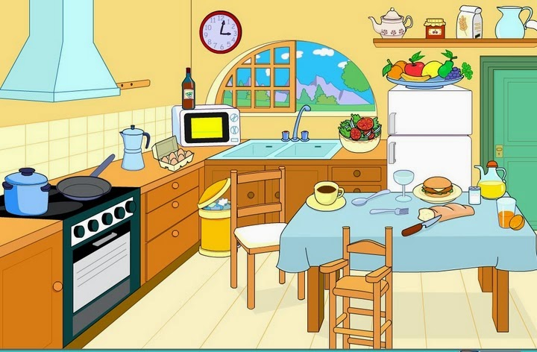

https://www.google.com/search?q=DIBUJOS+DE+ENTORNOS+ESCOLARES&tbm=isch&tbs=rimg:CRxQXWngXfFZIjiUoqpg4wFp_1gvh9EGfQoJat4XOWgo0qbBbzdSnDJyIdlGfFMPBCHdfM9Qeg7C3OLypw_10At4S0JyoSCZSiqmDjAWn-EQOp8NYYs5P0KhIJC-H0QZ9CgloRpjqam0v4otsqEgm3hc5aCjSpsBEmHJ_1DU5xjIioSCVvN1KcMnIh2Edop3aGU_1IKvKhIJUZ8Uw8EId18RFP9ERyJwkZEqEgkz1B6DsLc4vBHZ9ngLXIfxzioSCanD_1QC3hLQnEd4PHDAfri23&tbo=u&sa=X&ved=2ahUKEwjp58m46_rgAhXHxVkKHQo7DgAQ9C96BAgBEBs&biw=1366&bih=576&dpr=1#imgrc=M9Qeg7C3OLykXM:

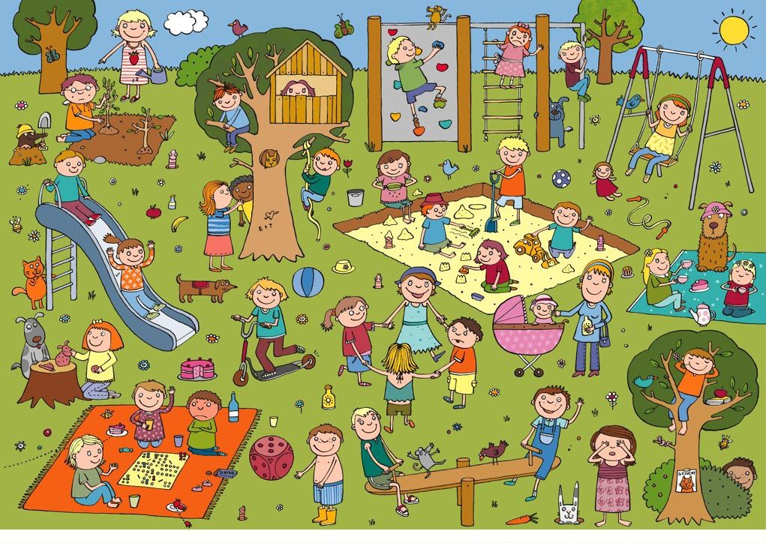

https://www.google.com/search?q=DIBUJOS+DE+PARQUES&tbm=isch&tbs=rimg:CREfy3ENVKZnIjjwOsvSWVZWv3I82_11jfHJ-5DwoDCEO4GMl1qiW_1BgaduhIrQPS17E57VAUYW6mhU7Lj2Pt1a05sCoSCfA6y9JZVla_1EUhgYtawS5rBKhIJcjzb_1WN8cn4RR_1HEQA28UnIqEgnkPCgMIQ7gYxH8G_1FcKwsPFSoSCSXWqJb8GBp2ET7wKlupDhZCKhIJ6EitA9LXsTkRqhVhq1rDNUcqEgntUBRhbqaFThGXjsBuoqpZZyoSCcuPY-3VrTmwEe2VQghrsMoW&tbo=u&sa=X&ved=2ahUKEwjvgY6O7PrgAhUCyFkKHbbeAjIQ9C96BAgBEBs&biw=1366&bih=576&dpr=1#imgrc=gBkItTYwM4aMGM:

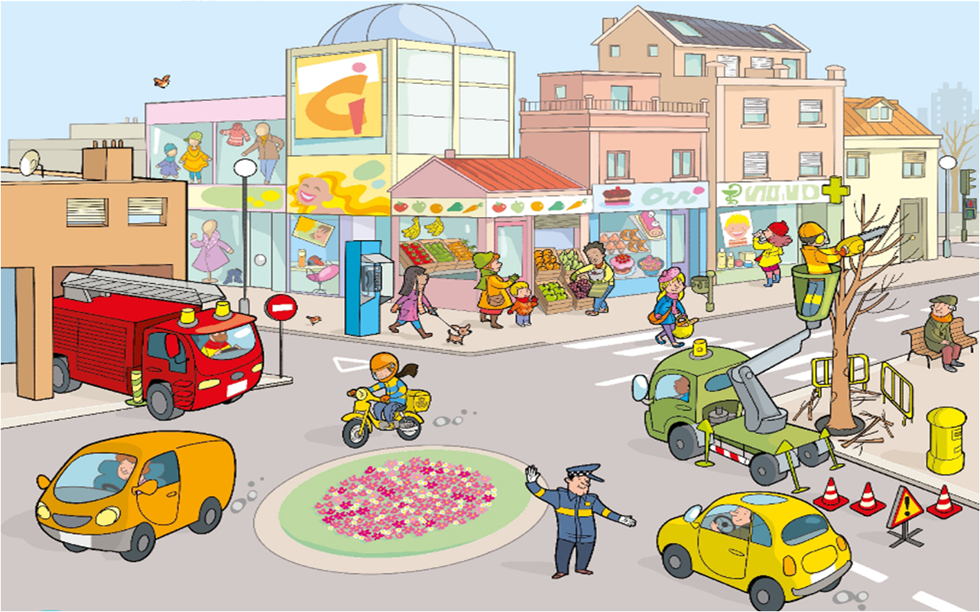https://www.google.com/search?q=DIBUJOS+DE+CIUDADES&tbm=isch&tbs=rimg:CcdSMuDluHlrIjiaws1Yx-7vtQsPbr45qHs6Y87vr2HcQ9OYa8C8XmWUTgccqQLAZvaEwfMv9zX2w9w9YtXBV88VMyoSCZrCzVjH7u-1EabKTa20YrGqKhIJCw9uvjmoezoRB009DEqCjCQqEgljzu-vYdxD0xEYnFRdREGBRSoSCZhrwLxeZZROETcYkViSYVYvKhIJBxypAsBm9oQRaDCSjRkg3QsqEgnB8y_13NfbD3BEO_1RJ8xNPY7yoSCT1i1cFXzxUzEVbu48uefIIC&tbo=u&sa=X&ved=2ahUKEwiqs5K_7frgAhXus1kKHeHpANoQ9C96BAgBEBs&biw=1366&bih=576&dpr=1#imgrc=wfMv9zX2w9wZLM:

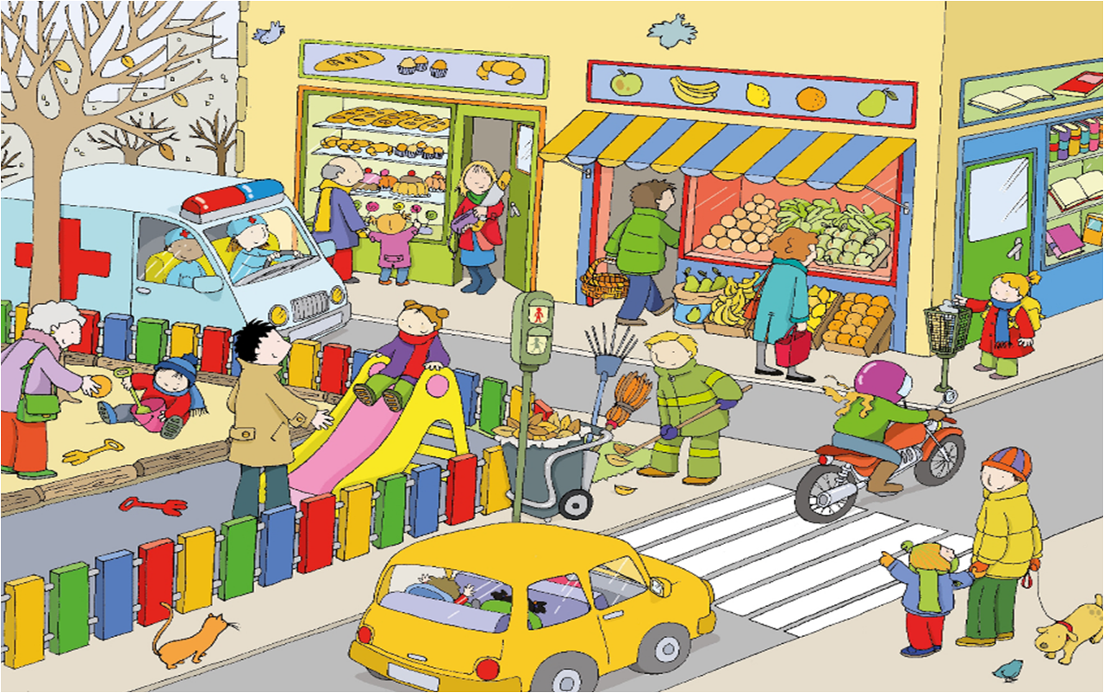

<https://www.google.com/search?q=DIBUJOS+DE+CIUDADES&tbm=isch&tbs=rimg:CcdSMuDluHlrIjiaws1Yx-7vtQsPbr45qHs6Y87vr2HcQ9OYa8C8XmWUTgccqQLAZvaEwfMv9zX2w9w9YtXBV88VMyoSCZrCzVjH7u-1EabKTa20YrGqKhIJCw9uvjmoezoRB009DEqCjCQqEgljzu-YdxD0xEYnFRdREGBRSoSCZhrwLxeZZROETcYkViSYVYvKhIJBxypAsBm9oQRaDCSjRkg3QsqEgnB8y_13NfbD3BEO_1RJ8xNPY7yoSCT1i1cFXzxUzEVbu48uefIIC&tbo=u&sa=X&ved=2ahUKEwiqs5K_7frgAhXus1kKHeHpANoQ9C96BAgBEBs&biw=1366&bih=576&dpr=1#imgdii=oDnOHQHbxjWoyM:&imgrc=wfMv9zX2w9wZLM>:

**ACCIDENTE DEPORTIVO**

**ACTIVIDAD EVALUATIVA**

|  |  |  |  |  |  |  |  |  |  |  |  |
| --- | --- | --- | --- | --- | --- | --- | --- | --- | --- | --- | --- |
| a | c | c | i | d | e | n | t | e | s | j | d |
| u | g | r | w | e | s | g | u | i | n | c | e |
| j | o | r | q | p | b | t | s | b | l | l | d |
| s | a | b | i | o | r | u | q | r | u | o | i |
| q | r | y | k | r | f | j | a | f | x | l | s |
| z | u | g | o | t | v | a | z | v | a | y | c |
| c | t | o | l | i | t | d | w | t | c | h | a |
| r | c | l | p | v | g | i | s | b | i | n | p |
| t | a | p | q | o | b | a | x | y | o | u | a |
| p | r | e | v | e | n | c | i | o | n | j | c |
| g | f | h | a | w | y | m | e | h | n | m | i |
| b | t | n | z | s | h | j | d | n | i | i | d |
| h | g | u | w | c | n | l | c | u | k | o | a |
| a | u | t | o | c | u | i | d | a | d | o | d |
| m | o | t | o | r | a | m | n | v | c | x | a |

ACCIDENTE

DEPORTIVO

PREVENCION

GOLPE

CAIDA

FRACTURA

LUXACION

ESGUINCE

DISCAPACIDAD

AUTOCUIDADO

MOTORA